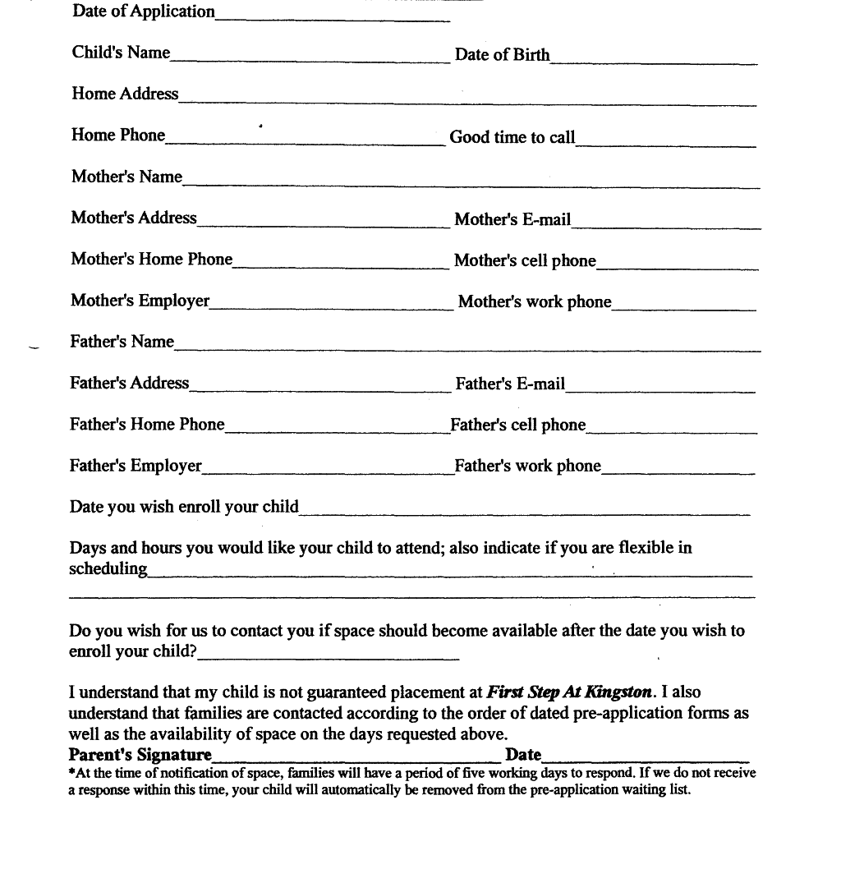

Lexony’s Kiddie College
Pre-Application Form
Waiting List
Lexony’s Kiddie College
Phone: (413) 2124200
52 Bossidy Drive
Pittsfield, MA 01201

